REDD+ Feasability Assessment

Potential activity data and allocated deforestation risk for Liberia and the RSPB project area

2025-01-19

## Summary

This analysis of the RSPB Gola REDD+ project documents workflow used to derive preliminary Activity Data and Deforestation Risk Maps, including baseline estimates of forest change and jurisdictional allocated deforestation.

##### Table 1: Project files reviewed in this assessment

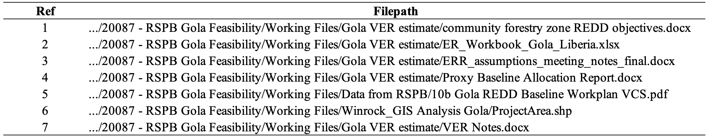

*Import AOI & visualize:*

set.seed(77777)  
# Import project aoi  
aoi = sf::read_sf("./data/aoi/AllLandscapes_merge_v02.shp") |>   
 sf::st_cast("POLYGON") |> sf::st_cast("MULTIPOLYGON") |>   
 dplyr::select(Name) |> sf::st_transform(4326) |>  
 dplyr::filter(  
 Name == "Gola Forest National Park" |   
 Name == "Norman" |   
 Name == "Tonglay")   
  
aoi_gola = aoi |> dplyr::filter(Name == "Gola Forest National Park")  
aoi_tong = aoi |> dplyr::filter(Name == "Tonglay")  
aoi_norm = aoi |> dplyr::filter(Name == "Norman")  
  
# Import country aoi  
query = osmdata::opq("Liberia") |> # opq = overpass query  
 osmdata::add_osm_feature(key = "boundary", value = "administrative") |>  
 osmdata::osmdata_sf()  
boundaries = query$osm_multipolygons  
country = boundaries |> dplyr::filter(admin_level == "2", name == "Liberia") |>  
 dplyr::select(name, admin_level, geometry) |> sf::st_cast() |> sf::st_transform(4326)  
sf::st_write(country, "./data/aoi/liberia_boundary_national.shp", delete_layer=T)

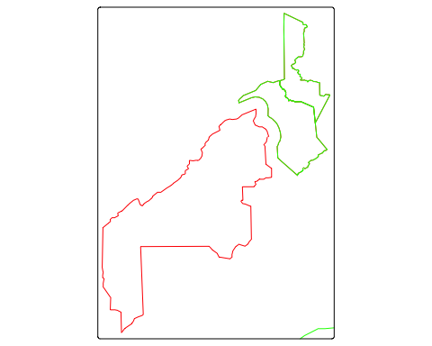



## Area check

In Liberia, the official definition of forest land is provided by the Forestry Development Authority (Liberia 2019), including areas of land that meet the following criteria:

* Canopy cover of minimum 30%;
* Canopy height of minimum 5m or the capacity to reach it;
* Covering a minimum of 1 hectare of land.

aoi$area_ha = round(as.numeric(sf::st_area(aoi) * 0.0001, 4))  
aoi |> sf::st_drop_geometry() |> janitor::adorn_totals()

Name area_ha  
 Gola Forest National Park 89050  
 Tonglay 19593  
 Norman 12298  
 Total 120941

aoi_comm$area_ha = round(as.numeric(sf::st_area(aoi_comm) * 0.0001, 4))  
aoi_comm |> sf::st_drop_geometry() |> janitor::adorn_totals()

id name area hectares acre No County Step_level  
 <NA> Buluyeama NA <NA> <NA> 7 Lofa Step 1-9  
 <NA> Tonglay NA <NA> <NA> 53 Gbarpolu Step 1-5  
 <NA> Bondi Mandingo NA <NA> <NA> 6 Gbarpolu Step 1-9  
 <NA> Bokomu NA <NA> <NA> 5 Gbarpolu Step 1-6  
 <NA> Norman NA <NA> <NA> 40 Gbarpolu Step 1-5  
 <NA> Buluyeama Community Forest NA <NA> <NA> 7 Lofa Step 1-9  
 <NA> Korninga A Community Forest NA <NA> <NA> 28 Gbarpolu Step 1-9  
 <NA> Salayea NA <NA> <NA> 46 Lofa Step 1-9  
 <NA> Korninga B Community Forest NA <NA> <NA> 29 Gbarpolu Step 1-9  
 Total - 0 - - - - -  
 Sponsor Status Date_appve Expri_date CFMP_Statu  
 FDA Active <NA> <NA> Active  
 SCNL Ongoing <NA> <NA> Ongoing  
 FDA Active December 27, 2018 December 27, 2033 Approved  
 FDA Ongoing N/A N/A Ongoing  
 SCNL Ongoing <NA> <NA> Ongoing  
 FDA Active January 10, 2012 January 10, 2017 Active  
 FDA Active January 18, 2018 January 18, 2033 Approved  
 World Bank Active <NA> <NA> Active  
 FDA Active August 31, 2018 August 31, 2033 Approved  
 - - - - -  
 CFMP_Focus Area_Ha Area_acres Creat_date Crted_User  
 Commercial <NA> <NA> <NA> GIS Division  
 <NA> <NA> <NA> <NA> GIS Lab  
 Commercial Forestry 31318 <NA> July 16, 2019 GIS Division  
 N/A 33472 <NA> July 16, 2019 GIS Division  
 <NA> <NA> <NA> <NA> GIS Lab  
 Commercial Forestry 49,444 <NA> July 16, 2019 GIS Division  
 Commercial Forestry 48296 <NA> July 16, 2019 GIS Division  
 Commercial <NA> <NA> <NA> GIS Lab  
 Commercial Forestry 31818 <NA> July 16, 2019 GIS Division  
 - - - - -  
 Descriptio Region Last_updat Data_Sourc Receipt_No hectare  
 Community Forest Region 2 July 16, 2019 FDA GIS Division <NA> NA  
 Community Forest Region 1 July 16, 2019 FDA GIS Division 64847 19594  
 Community Forest Region 1 July 16, 2019 FDA GIS Division 62545 37187  
 Community Forest Region 1 July 16, 2019 FDA GIS Division N/A 33487  
 Community Forest Region 1 July 16, 2019 <NA> <NA> 12299  
 Community Forest Region 2 July 16, 2019 FDA GIS Division N/A 49966  
 Community Forest Region 1 July 16, 2019 FDA GIS Division 69206 48310  
 Community Forest Region 2 July 16, 2019 FDA GIS Lab 115313 8276  
 Community Forest Region 1 July 16, 2019 FDA GIS Division 69224 31827  
 - - - - - 240946  
 Acres layer  
 <NA> buluyeama_cf  
 4841671 Cmmunity_forest_update_032020  
 9189064 Cmmunity_forest_update_032020  
 8274900 Cmmunity_forest_update_032020  
 3039040 Cmmunity_forest_update_032020  
 12346963 Cmmunity_forest_update_032020  
 11937677 Cmmunity_forest_update_032020  
 2044925 Cmmunity_forest_update_032020  
 7864523 Cmmunity_forest_update_032020  
 - -  
 path  
 C:/Users/Mr. Johnson/Documents/file frm old PC/Community Forest & PAs-PPAs Data 2020-/Buluyeama_CF/buluyeama_cf.shp  
 C:/Users/Mr. Johnson/Documents/file frm old PC/Community Forest & PAs-PPAs Data 2020-/community forests undate 2020/Cmmunity_forest_update_032020.shp  
 C:/Users/Mr. Johnson/Documents/file frm old PC/Community Forest & PAs-PPAs Data 2020-/community forests undate 2020/Cmmunity_forest_update_032020.shp  
 C:/Users/Mr. Johnson/Documents/file frm old PC/Community Forest & PAs-PPAs Data 2020-/community forests undate 2020/Cmmunity_forest_update_032020.shp  
 C:/Users/Mr. Johnson/Documents/file frm old PC/Community Forest & PAs-PPAs Data 2020-/community forests undate 2020/Cmmunity_forest_update_032020.shp  
 C:/Users/Mr. Johnson/Documents/file frm old PC/Community Forest & PAs-PPAs Data 2020-/community forests undate 2020/Cmmunity_forest_update_032020.shp  
 C:/Users/Mr. Johnson/Documents/file frm old PC/Community Forest & PAs-PPAs Data 2020-/community forests undate 2020/Cmmunity_forest_update_032020.shp  
 C:/Users/Mr. Johnson/Documents/file frm old PC/Community Forest & PAs-PPAs Data 2020-/community forests undate 2020/Cmmunity_forest_update_032020.shp  
 C:/Users/Mr. Johnson/Documents/file frm old PC/Community Forest & PAs-PPAs Data 2020-/community forests undate 2020/Cmmunity_forest_update_032020.shp  
 -  
 area_ha  
 49937  
 19593  
 37182  
 33472  
 12298  
 49937  
 48296  
 8270  
 31818  
 290803

aoi_tong2$area_ha = round(as.numeric(sf::st_area(aoi_tong2) * 0.0001, 4))  
aoi_tong2 |> sf::st_drop_geometry() |> janitor::adorn_totals()

id name area hectares acre No County Step_level Sponsor  
 0 Tonglay 0 19592.8624691772 <NA> 53 Gbarpolu Step 1-5 SCNL  
 Total - 0 - - - - - -  
 Status Date_appve Expri_date CFMP_Statu CFMP_Focus Area_Ha Area_acres  
 Ongoing <NA> <NA> Ongoing <NA> <NA> <NA>  
 - - - - - - -  
 Creat_date Crted_User Descriptio Region Last_updat Data_Sourc  
 <NA> GIS Lab Community Forest Region 1 July 16, 2019 FDA GIS Division  
 - - - - - -  
 Receipt_No hectare Acres layer  
 64847 19594 4841671 Cmmunity_forest_update_032020  
 - 19594 - -  
 path  
 C:/Users/Mr. Johnson/Documents/file frm old PC/Community Forest & PAs-PPAs Data 2020-/community forests undate 2020/Cmmunity_forest_update_032020.shp  
 -  
 area_ha  
 19593  
 19593

aoi_norm2$area_ha = round(as.numeric(sf::st_area(aoi_norm2) * 0.0001, 4))  
aoi_norm2 |> sf::st_drop_geometry() |> janitor::adorn_totals()

id name area hectares acre No County Step_level Sponsor Status  
 0 Norman 0 12297.8514030695 <NA> 40 Gbarpolu Step 1-5 SCNL Ongoing  
 Total - 0 - - - - - - -  
 Date_appve Expri_date CFMP_Statu CFMP_Focus Area_Ha Area_acres Creat_date  
 <NA> <NA> Ongoing <NA> <NA> <NA> <NA>  
 - - - - - - -  
 Crted_User Descriptio Region Last_updat Data_Sourc Receipt_No  
 GIS Lab Community Forest Region 1 July 16, 2019 <NA> <NA>  
 - - - - - -  
 hectare Acres layer  
 12299 3039040 Cmmunity_forest_update_032020  
 12299 - -  
 path  
 C:/Users/Mr. Johnson/Documents/file frm old PC/Community Forest & PAs-PPAs Data 2020-/community forests undate 2020/Cmmunity_forest_update_032020.shp  
 -  
 area_ha  
 12298  
 12298

aoi_gola2$area_ha = round(as.numeric(sf::st_area(aoi_gola2) * 0.0001, 4))  
aoi_gola2 |> sf::st_drop_geometry() |> janitor::adorn_totals()

Name PL layer admin0Name admin0Pcod  
 Gola Forest National Park Gola-Foya Gola_v02 Liberia LR  
 Total - - - -  
 Area_ha Shape_Leng Shape_Area area_ha  
 7.29357535798754E-06 183293.1 890503920 89050  
 - 183293.1 890503920 89050

slivers = aoi |> dplyr::filter(as.numeric(area_ha) < 1) # no artefacts found

Results indicate the spatial dataset is free from topological errors, and forest ‘islands’ and spatial artefacts smaller than approved area definition. Results also match Areahav2 values derived previously and reported in ER_Workbook_Gola_Liberia.xlsx

## Activity data check

This section documents inputs and procedures used to derive national and project-level deforestation maps. This follows three main steps:

* Compare land cover training samples for Liberia;
* Classify & assess accuracy of forest cover maps for 2014, 2019, and 2024;
* Spatially map deforestation risk, allocate jurisdictional deforestation & compare with FREL.

#### Training samples

Training samples for the country and project area were extracted from two gold standard global land cover time series datasets: the GLanCE dataset (Stanimirova et al. 2023) and TimeSpec4LULC dataset. Both training datasets were processed with continuous change and class migration algorithms. While Verra is yet to establish requirements for addressing feature class migration in classification of baseline activity data (Verra 2023, 2024, 2021), we may recommend incorporating this remote sensing best practice or showcase its improvements to accuracy metrics, as follows.

##### Table 2: Class conversions of training samples

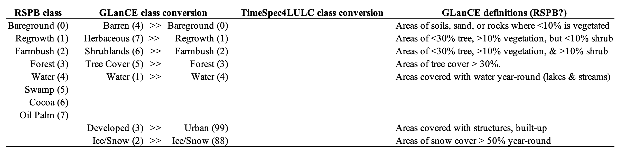

Level-1 classes in the GLanCE and TimeSpec4LULC datasets were recoded below to match class labels cited in the “Lookups” sheet of “ER_Workbook_Gola_Liberia.xlsx”, and the report titled “Liberia’s Forest Reference Emission Level Submission to the UNFCCC (Woodcock et al., n.d.; Liberia 2019).

To address class imbalances, the Winrock team derived additional training samples and appended to the GLanCE datapoint collection. This sampling aimed to improve class-to-country proportionality while targeting plot-to-pixel dimensions and homogenous rule throughout training sample selection.

# import & tidy samples  
samples_raw = read.csv("./data/training_samples/glance_training.csv")  
samples_clean = samples_raw |>  
 dplyr::select(Lon, Lat, Glance_Class_ID_level1, Start_Year, End_Year)|>  
 dplyr::rename(longitude = Lon) |>  
 dplyr::rename(latitude = Lat) |>  
 dplyr::rename(label_old = Glance_Class_ID_level1) |>  
 dplyr::mutate(start_date = as.Date(paste(Start_Year,"01","01",sep = "-")))|>  
 dplyr::mutate(end_date = as.Date(paste(End_Year, "01", "01", sep = "-")))|>  
 dplyr::select(longitude, latitude, start_date, end_date, label_old)|>  
 dplyr::mutate(code = case_when(  
 label_old == '4' ~ 0,   
 label_old == '7' ~ 1,   
 label_old == '6' ~ 2,   
 label_old == '5' ~ 3,   
 label_old == '1' ~ 4,   
 label_old == '3' ~ 99,   
 label_old == '2' ~ 88)  
 ) |>  
 dplyr::mutate(label = case_when(  
 code == '0' ~ "Bareground",   
 code == '1' ~ "Regrowth",   
 code == '2' ~ "Farmbush",   
 code == '3' ~ "Forest",   
 code == '4' ~ "Water",   
 code == '99' ~ "Urban",   
 code == '88' ~ "Snow")  
 ) |>   
 dplyr::mutate(label = as.factor(label)) |>  
 dplyr::mutate(id = row_number()) |>   
 dplyr::select(-label_old)  
  
# filter to project area  
samples_sf = sf::st_as_sf(samples_clean, crs = 4326, coords = c("longitude", "latitude"))  
samples_clipped = sf::st_intersection(samples_sf, country) # n = 364  
samples_country = samples_sf[samples_clipped, ] |> sf::st_transform(4326)  
samples = sf::st_crop(samples_country, st_bbox(country))  
sf::st_write(samples, "./data/training_samples/glance_spatial_clip.shp", delete_dsn = T)  
write.csv(samples, "./data/training_samples/glance_spatial_clip.csv", row.names = F)  
dplyr::count(samples, label)  
  
# Winrock training samples  
samples_winrock <- sf::st_read("./data/training_samples/samples_winrock3.shp") |> sf::st_cast() |> sf::st_transform(4326)  
#samples_winrock <- sf::st_read("./data/training_samples/samples_winrock2.shp") |> sf::st_cast() |> sf::st_transform(4326)  
#samples_winrock <- sf::st_read("./data/training_samples/samples_winrock.shp") |> sf::st_cast() |> sf::st_transform(4326)  
samples_winrock <- samples_winrock |>  
 dplyr::select(Name)|>  
 dplyr::mutate(  
 start_date = as.Date("2014-01-01"),  
 end_date = as.Date("2024-01-01"),  
 id = row_number()  
 )  
  
samples_winrock$label <- case_when(  
 stringr::str_detect(samples_winrock$Name, "^Bareland") ~ "Bareground",  
 stringr::str_detect(samples_winrock$Name, "^Regrowth") ~ "Regrowth",  
 stringr::str_detect(samples_winrock$Name, "^Farmbush") ~ "Farmbush",  
 stringr::str_detect(samples_winrock$Name, "^Forest") ~ "Forest",  
 stringr::str_detect(samples_winrock$Name, "^Water") ~ "Water",  
 stringr::str_detect(samples_winrock$Name, "^Swamp") ~ "Swamp",  
 TRUE ~ "MISSING"  
 ) |> as.factor()  
  
samples_winrock$code <- case_when(  
 samples_winrock$label == "Bareground" ~ 0,  
 samples_winrock$label == "Regrowth" ~ 1,  
 samples_winrock$label == "Farmbush" ~ 2,  
 samples_winrock$label == "Water" ~ 4,  
 samples_winrock$label == "Swamp" ~ 5,  
 TRUE ~ NA_real_ # Use NA_real_ for numeric NA  
)  
  
samples_winrock <- samples_winrock[!(samples_winrock$label == "Forest"), ]  
samples_winrock$label <- droplevels(samples_winrock$label)  
  
samples_winrock <- samples_winrock |>  
 dplyr::select(-Name)  
samples_combined <- rbind(samples, samples_winrock)  
st_write(samples_combined, "./data/training_samples/samples_combined.shp", delete_dsn=T)  
samples = sf::st_read("./data/training_samples/samples_combined.shp")  
dplyr::count(samples, label)

Reading layer `samples_combined' from data source   
 `/Users/seamus/repos/rspb-redd-risk-new/data/training_samples/samples_combined.shp'   
 using driver `ESRI Shapefile'  
Simple feature collection with 389 features and 5 fields  
Geometry type: POINT  
Dimension: XY  
Bounding box: xmin: -11.41444 ymin: 4.608361 xmax: -7.579165 ymax: 8.353939  
Geodetic CRS: WGS 84

Simple feature collection with 7 features and 2 fields  
Geometry type: MULTIPOINT  
Dimension: XY  
Bounding box: xmin: -11.41444 ymin: 4.608361 xmax: -7.579165 ymax: 8.353939  
Geodetic CRS: WGS 84  
 label n geometry  
1 Bareground 7 MULTIPOINT ((-10.73235 7.56...  
2 Farmbush 7 MULTIPOINT ((-11.35816 6.81...  
3 Forest 311 MULTIPOINT ((-11.41444 6.96...  
4 Regrowth 18 MULTIPOINT ((-10.85522 7.53...  
5 Swamp 3 MULTIPOINT ((-10.84405 7.54...  
6 Urban 37 MULTIPOINT ((-10.78342 6.36...  
7 Water 6 MULTIPOINT ((-11.26555 6.76...

#### Raster collection

The dataset of STAC-formatted Landsat Collection-2-Level-2 was extracted from the Google Earth Engine Catalog and processed using a cloudless and pixel quality ranking mask before back-filling with median normalization. This was implemented in a [Colab python runtime here](https://colab.research.google.com/github/seamusrobertmurphy/01-data-processing/blob/main/01-data-processing.ipynb). The collection of unclassified rasters was temporarily stored in a [Google Drive folder](https://drive.google.com/drive/folders/1XMYYhBUAsvuZ02avsZHYHDTArqztLaFI?usp=drive_link) and the consolidated, resampled and labelled full stack is available to download directly from [here](https://drive.google.com/file/d/1Vn0KDzkFDaBhpdC803IbYVRuu5cHx0SO/view?usp=drive_link). In addition, full script and all runtime setups are available from the project’s github repository here

Landsat data was acquired instead of Sentinel imagery due to start date of project’s 10-year baseline occurring before the launch of the Sentinel 2 satellite. The following chunk provides an alternative worflow, though less reliable, R-native workflow for acquiring, aligning, and processing rasters for the extent of Liberia.

The processes above were repeated for three baseline interval years of 2014, 2019, and 2024 and then saved into consolidated raster stack and visualized below.

# import  
NDVI_2014=terra::rast("./data/STACK/LANDSAT_TM-ETM-OLI_198055_NDVI_2014-01-04.tif")  
NDVI_2019=terra::rast("./data/STACK/LANDSAT_TM-ETM-OLI_198055_NDVI_2019-01-02.tif")  
NDVI_2024=terra::rast("./data/STACK/LANDSAT_TM-ETM-OLI_198055_NDVI_2024-01-16.tif")  
STACK=raster::brick("./data/STACK/LANDSAT_TM-ETM-OLI_198055_STACK-&-DEM_2014-01-04_2024-01-16_INTERP.tif")  
  
# visualize  
hist(NDVI_2014, main = "NDVI Distribution, 2014", col = "springgreen")   
hist(NDVI_2019, main = "NDVI Distribution, 2019", col = "springgreen")  
hist(NDVI_2024, main = "NDVI Distribution, 2024", col = "springgreen")  
plot(NDVI_2014,main="NDVI, 2014",xlim=c(-11.5,-7.5),ylim=c(4.1,8.6),border="gray")  
plot(st_geometry(samples), add=T)  
plot(NDVI_2019,main="NDVI, 2014",xlim=c(-11.5,-7.5),ylim=c(4.1,8.6),border="gray")  
plot(st_geometry(samples), add=T)  
plot(NDVI_2024,main="NDVI, 2014",xlim=c(-11.5,-7.5),ylim=c(4.1,8.6),border="gray")  
plot(st_geometry(samples), add=T)

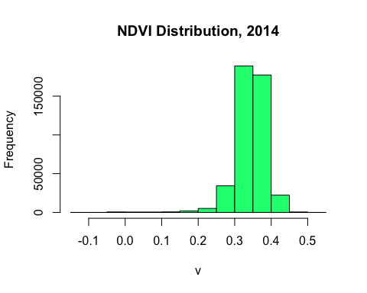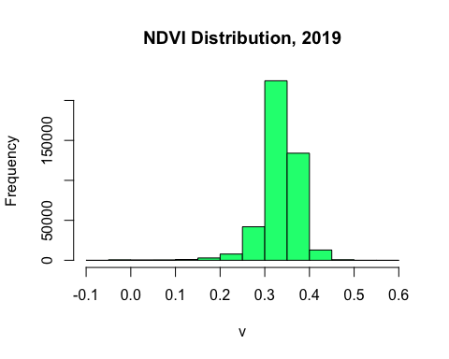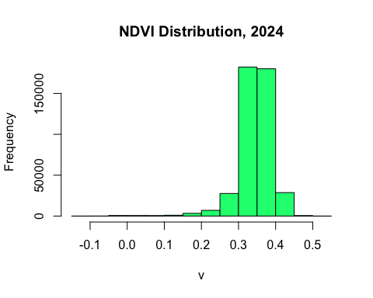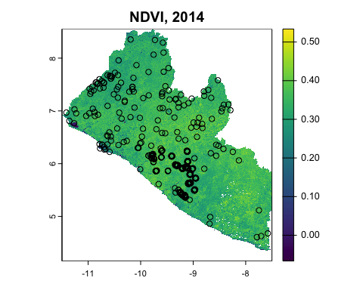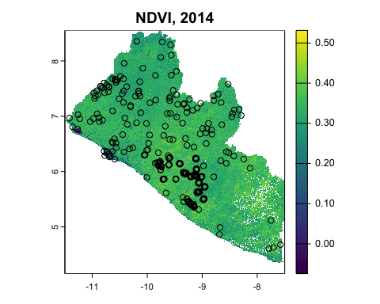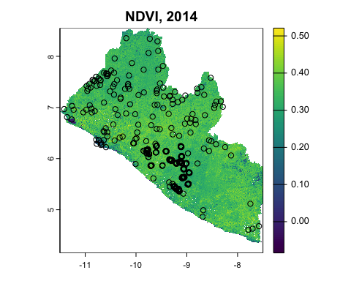

#### Image classification

We trained a Random Forest model fitted with 500 decision trees. The dataset was partitioned using a 70:30 ratio which was which was trained using Monte Carlo resampling regime (k=100). Accuracy assessments were reported using a confusion matrix. Uncertainty metrics were then used to explore best subset of variables according to magnitude and performances of recursive modeling, which informed final model selection.

# extract signatures  
signatures_2014 = raster::extract(STACK_2014, samples ,df=T) # watch for data formats  
samples_signatures_2014 <- dplyr::inner_join(signatures_2014, samples, by=c("ID"="id"))  
samples_signatures_2014$geometry <- NULL # set geometry to NULL for model training  
  
# Stratify to ensure all classes are present in both train and test  
stratified_partition <- function(data, group_col, train_ratio = 0.7) {  
 split_data <- lapply(split(data, data[[group_col]]), function(df) {  
 train_size <- max(1, floor(train_ratio * nrow(df)))  
 train_idx <- sample(seq_len(nrow(df)), size = train_size)  
 list(train = df[train_idx, ], test = df[-train_idx, ])  
 })  
 train_data <- do.call(rbind, lapply(split_data, `[[`, "train"))  
 test_data <- do.call(rbind, lapply(split_data, `[[`, "test"))  
 list(train = train_data, test = test_data)  
 }  
partitioned_data_2014 <- stratified_partition(samples_signatures_2014,group_col="label", train_ratio=0.7)  
trainData_2014 <- partitioned_data_2014$train  
testData_2014 <- partitioned_data_2014$test  
#table(trainData_2014$label)  
#table(testData_2014$label)  
  
# synthetic minotrity oversampling technique  
trainData_2014<-performanceEstimation::smote(label ~ .,data=trainData_2014,perc.over=30,perc.under=30)  
testData_2014<-performanceEstimation::smote(label ~ .,data=testData_2014,perc.over=30,perc.under=30)  
# interpolate missing cloud pixels with class-median-normalization  
trainData_2014 <- trainData_2014 |> group_by(label) |> mutate(across(where(is.numeric),  
 ~ ifelse(is.na(.), median(., na.rm = T), .))) |> ungroup()  
testData_2014 <- testData_2014 |> group_by(label) |> mutate(across(where(is.numeric),  
 ~ ifelse(is.na(.), median(., na.rm = T), .))) |> ungroup()  
  
# assign model variables  
response <- c("label")  
predictors_2014 <- c(  
 "NDVI_2014", "BLUE_2014", "GREEN_2014", "RED_2014",   
 "NIR08_2014", "SWIR16_2014", "SWIR22_2014", "DEM"  
 )  
# set training parameters  
cv_regime <- caret::trainControl(  
 method = 'LGOCV',  
 number = 100,  
 savePredictions = T,  
 verboseIter = F  
 )  
  
# train classifier  
rf_model_2014 <- caret::train(  
 label~.,  
 data = trainData_2014[, c(predictors_2014, "label")], # drop ID var  
 trControl = cv_regime,  
 method = "rf",   
 metric = 'Kappa',   
 ntree = 500,  
 tuneLength= 6,  
 importance= T  
 )

***Accuracy assessments***[1]

Results suggested a moderate concordance between observed and predicted classes with optimal model performance during cross-validation at mtry of 3. Overall statistics reported Kappa Index of 71.04%, Accuracy of 88.61% (0.95CI 84.46%, 95.71%), and a smaller No Information Rate of 0.8158 (p<0.01). In addition, key classes of Forest were predicted with robust Sensitivity (98.92%) and Specificity (76.16%).

To address model weaknesses, the team recommends sourcing additional verified training samples, or alternatively applying a weighted Random Forest, Gradient Boosting or Support Vector Machines kernels (SVM) to improve performance of underrepresented classes. Note, these modeling updates will require substantial runtimes.

rf_test_2014 <- predict(rf_model_2014, testData_2014)  
print(rf_model_2014) # cv results  
caret::confusionMatrix(rf_test_2014,testData_2014$label) # blind test results

Random Forest   
  
1862 samples  
 8 predictor  
 7 classes: 'Bareground', 'Farmbush', 'Forest', 'Regrowth', 'Swamp', 'Urban', 'Water'   
  
No pre-processing  
Resampling: Repeated Train/Test Splits Estimated (100 reps, 75%)   
Summary of sample sizes: 1399, 1399, 1399, 1399, 1399, 1399, ...   
Resampling results across tuning parameters:  
  
 mtry Accuracy Kappa   
 2 0.9976674 0.9935532  
 3 0.9976674 0.9935535  
 4 0.9976674 0.9935553  
 5 0.9976674 0.9935596  
 6 0.9976674 0.9935626  
 8 0.9976674 0.9935652  
  
Kappa was used to select the optimal model using the largest value.  
The final value used for the model was mtry = 8.  
Confusion Matrix and Statistics  
  
 Reference  
Prediction Bareground Farmbush Forest Regrowth Swamp Urban Water  
 Bareground 28 8 0 0 0 3 0  
 Farmbush 0 10 0 0 0 0 0  
 Forest 4 0 696 8 0 0 0  
 Regrowth 0 0 8 41 0 0 0  
 Swamp 0 0 0 0 31 0 0  
 Urban 0 4 0 0 0 80 0  
 Water 0 0 0 0 0 0 10  
  
Overall Statistics  
   
 Accuracy : 0.9624   
 95% CI : (0.9481, 0.9737)  
 No Information Rate : 0.7562   
 P-Value [Acc > NIR] : < 2.2e-16   
   
 Kappa : 0.9086   
   
 Mcnemar's Test P-Value : NA   
  
Statistics by Class:  
  
 Class: Bareground Class: Farmbush Class: Forest Class: Regrowth Class: Swamp Class: Urban  
Sensitivity 0.87500 0.45455 0.9886 0.83673 1.0000 0.96386  
Specificity 0.98776 1.00000 0.9471 0.99093 1.0000 0.99528  
Pos Pred Value 0.71795 1.00000 0.9831 0.83673 1.0000 0.95238  
Neg Pred Value 0.99552 0.98697 0.9641 0.99093 1.0000 0.99646  
Prevalence 0.03437 0.02363 0.7562 0.05263 0.0333 0.08915  
Detection Rate 0.03008 0.01074 0.7476 0.04404 0.0333 0.08593  
Detection Prevalence 0.04189 0.01074 0.7605 0.05263 0.0333 0.09023  
Balanced Accuracy 0.93138 0.72727 0.9679 0.91383 1.0000 0.97957  
 Class: Water  
Sensitivity 1.00000  
Specificity 1.00000  
Pos Pred Value 1.00000  
Neg Pred Value 1.00000  
Prevalence 0.01074  
Detection Rate 0.01074  
Detection Prevalence 0.01074  
Balanced Accuracy 1.00000

#### Model calibration

We employed recursive predictor subsetting to identify predictors of greatest magnitude and non-informative features to enhance model performance and reduce model complexity, respectively. This aims to limit potential of multicolinearity, despite inherent robustness of randomForest algorithms against such violations. The subsetted model was evaluated on the test dataset. The confusion matrix and performance metrics were summarized below.

index_feature_2014 <- createMultiFolds(trainData_2014$label, times=5)   
predictor_seq_2014 <-seq(from=1, to=length(predictors_2014),by=2)  
  
subset_regime_2014 <- rfeControl(  
 method="LGOCV",  
 number = 10,  
 verbose=FALSE,  
 functions=rfFuncs,  
 index=index_feature_2014  
 )  
  
rf_model_subset_2014 <- caret::rfe(  
 label~.,  
 data = trainData_2014[, c(predictors_2014, "label")],   
 sizes = predictor_seq_2014,  
 metric = "Kappa",  
 ntree=500,  
 method="rf",  
 rfeControl = subset_regime_2014  
 )  
  
rf_subset_test_2014 <- predict(rf_model_subset_2014,testData_2014)  
print(rf_model_subset_2014)

Recursive feature selection  
  
Outer resampling method: Repeated Train/Test Splits Estimated (50 reps, 75%)   
  
Resampling performance over subset size:  
  
 Variables Accuracy Kappa AccuracySD KappaSD Selected  
 1 0.9974 0.9929 0.0038035 0.010585   
 3 0.9991 0.9976 0.0019897 0.005519   
 5 0.9995 0.9985 0.0016258 0.004489   
 7 0.9999 0.9997 0.0007603 0.002113 *  
 8 0.9998 0.9994 0.0010642 0.002957   
  
The top 5 variables (out of 7):  
 BLUE_2014, NDVI_2014, NIR08_2014, SWIR22_2014, SWIR16_2014

caret::confusionMatrix(rf_subset_test_2014$pred,testData_2014$label)

Confusion Matrix and Statistics  
  
 Reference  
Prediction Bareground Farmbush Forest Regrowth Swamp Urban Water  
 Bareground 21 0 0 0 0 0 0  
 Farmbush 0 0 0 0 0 0 0  
 Forest 0 14 709 17 31 16 0  
 Regrowth 0 0 0 24 0 0 0  
 Swamp 0 0 0 0 0 0 0  
 Urban 0 10 0 0 0 68 0  
 Water 0 0 7 0 0 0 14  
  
Overall Statistics  
   
 Accuracy : 0.898   
 95% CI : (0.8767, 0.9167)  
 No Information Rate : 0.7691   
 P-Value [Acc > NIR] : < 2.2e-16   
   
 Kappa : 0.7002   
   
 Mcnemar's Test P-Value : NA   
  
Statistics by Class:  
  
 Class: Bareground Class: Farmbush Class: Forest  
Sensitivity 1.00000 0.00000 0.9902  
Specificity 1.00000 1.00000 0.6372  
Pos Pred Value 1.00000 NaN 0.9009  
Neg Pred Value 1.00000 0.97422 0.9514  
Prevalence 0.02256 0.02578 0.7691  
Detection Rate 0.02256 0.00000 0.7615  
Detection Prevalence 0.02256 0.00000 0.8453  
Balanced Accuracy 1.00000 0.50000 0.8137  
 Class: Regrowth Class: Swamp Class: Urban Class: Water  
Sensitivity 0.58537 0.0000 0.80952 1.00000  
Specificity 1.00000 1.0000 0.98819 0.99237  
Pos Pred Value 1.00000 NaN 0.87179 0.66667  
Neg Pred Value 0.98126 0.9667 0.98124 1.00000  
Prevalence 0.04404 0.0333 0.09023 0.01504  
Detection Rate 0.02578 0.0000 0.07304 0.01504  
Detection Prevalence 0.02578 0.0000 0.08378 0.02256  
Balanced Accuracy 0.79268 0.5000 0.89886 0.99618

Recursive feature selection  
  
Outer resampling method: Repeated Train/Test Splits Estimated (50 reps, 75%)   
  
Resampling performance over subset size:  
  
  
The top 3 variables (out of 3):  
 BLUE_2014, DEM, SWIR22_2014  
  
Confusion Matrix and Statistics  
  
 Reference  
Prediction Bareground Farmbush Forest Regrowth Swamp Urban Water  
 Bareground 28 8 12 0 0 3 0  
 Farmbush 0 10 8 0 0 0 0  
 Forest 4 4 679 32 31 9 0  
 Regrowth 0 0 0 0 0 0 0  
 Swamp 0 0 0 0 0 10 0  
 Urban 0 0 5 17 0 61 0  
 Water 0 0 0 0 0 0 10  
  
Overall Statistics  
   
 Accuracy : 0.8464   
 95% CI : (0.8216, 0.869)  
 No Information Rate : 0.7562   
 P-Value [Acc > NIR] : 1.085e-11   
   
 Kappa : 0.5879   
   
 Mcnemar's Test P-Value : NA   
  
Statistics by Class:  
  
 Class: Bareground Class: Farmbush Class: Forest Class: Regrowth Class: Swamp Class: Urban Class: Water  
Sensitivity 0.87500 0.45455 0.9645 0.00000 0.00000 0.73494 1.00000  
Specificity 0.97442 0.99120 0.6476 1.00000 0.98889 0.97406 1.00000  
Pos Pred Value 0.54902 0.55556 0.8946 NaN 0.00000 0.73494 1.00000  
Neg Pred Value 0.99545 0.98686 0.8547 0.94737 0.96634 0.97406 1.00000  
Prevalence 0.03437 0.02363 0.7562 0.05263 0.03330 0.08915 0.01074  
Detection Rate 0.03008 0.01074 0.7293 0.00000 0.00000 0.06552 0.01074  
Detection Prevalence 0.05478 0.01933 0.8153 0.00000 0.01074 0.08915 0.01074  
Balanced Accuracy 0.92471 0.72287 0.8060 0.50000 0.49444 0.85450 1.00000  
  
  
   
   
Variables Accuracy Kappa AccuracySD KappaSD Selected  
1 1 0.9981 0.9949 0.003389 0.008870   
2 3 0.9994 0.9983 0.001759 0.004588 *  
3 5 0.9991 0.9978 0.001984 0.005188   
4 7 0.9989 0.9972 0.002423 0.006388   
5 8 0.9989 0.9972 0.002423 0.006388

|  | Variables  <S3: AsIs> | Accuracy  <S3: AsIs> | Kappa  <S3: AsIs> | AccuracySD  <S3: AsIs> | KappaSD  <S3: AsIs> | Selected  <S3: AsIs> |
| --- | --- | --- | --- | --- | --- | --- |
| 1 | 1 | 0.9981 | 0.9949 | 0.003389 | 0.008870 |  |
| 2 | 3 | 0.9994 | 0.9983 | 0.001759 | 0.004588 | * |
| 3 | 5 | 0.9991 | 0.9978 | 0.001984 | 0.005188 |  |
| 4 | 7 | 0.9989 | 0.9972 | 0.002423 | 0.006388 |  |
| 5 | 8 | 0.9989 | 0.9972 | 0.002423 | 0.006388 |  |

In summary, the subset model achieved an Accuracy of 88.58% and a Kappa Index of 0.6338. These metrics closely align with the results of the original model, suggesting minimal or no loss in predictive power despite using fewer predictors. Similarly, high-performing classes of Forest maintained sensitivity and specificity (SE = 0.9667, SP = 0.8462). Given that the reduction in complexity offered by the subsetted model does not provide significant benefits in this context, we recommend proceeding with the original model to make spatial predictions.

These modelling operations were repeated for 2019 and 2024 (see Appendix).

Spatial predictions were made using their respective models and outputs of classified LULC rasters were saved in the same Google Drive folder linked above in previous sections.

LULC_LIBERIA_2014=terra::rast("./data/LULC/LULC_LIBERIA_2014-01-04.tif")  
LULC_LIBERIA_2019=terra::rast("./data/LULC/LULC_LIBERIA_2019-01-02.tif")  
LULC_LIBERIA_2024=terra::rast("./data/LULC/LULC_LIBERIA_2024-01-16.tif")  
code_dict <- data.frame(id = c(1, 2, 3, 4, 5, 6, 7),  
 label = c("Bareground", "Farmbush", "Forest", "Regrowth", "Swamp", "Urban", "Water"))  
levels(LULC_LIBERIA_2014) <- code_dict  
levels(LULC_LIBERIA_2019) <- code_dict  
levels(LULC_LIBERIA_2024) <- code_dict  
zoi = sf::st_transform(aoi, 4326)  
voi = terra::vect(zoi)  
LULC_PROJECT_2014 = terra::crop(LULC_LIBERIA_2014, voi, mask=T)  
LULC_PROJECT_2019 = terra::crop(LULC_LIBERIA_2019, voi, mask=T)  
LULC_PROJECT_2024 = terra::crop(LULC_LIBERIA_2024, voi, mask=T)  
terra::plot(LULC_LIBERIA_2014, main="Land Cover, 2014")  
terra::plot(LULC_LIBERIA_2019, main="Land Cover, 2019")  
terra::plot(LULC_LIBERIA_2024, main="Land Cover, 2024")  
terra::plot(LULC_PROJECT_2014, main="Land Cover, 2014")  
terra::plot(LULC_PROJECT_2019, main="Land Cover, 2019")  
terra::plot(LULC_PROJECT_2024, main="Land Cover, 2024")  
  
mask_gola = terra::rast("./data/BINARY/mask_gola.tif")  
mask_tong = terra::rast("./data/BINARY/mask_tong.tif")  
mask_norm = terra::rast("./data/BINARY/mask_norm.tif")  
mask_project = terra::rast("./data/BINARY/mask_project.tif")  
mask_gola=terra::resample(mask_gola, LULC_PROJECT_2014)  
mask_tong=terra::resample(mask_tong, LULC_PROJECT_2014)  
mask_norm=terra::resample(mask_norm, LULC_PROJECT_2014)  
mask_project=terra::resample(mask_project, LULC_PROJECT_2014)  
  
pixel_area_ha <- 0.088914 # 29.80124 x 29.80124 m² converted to hectares  
compute_land_cover_summary <- function(zoi, rasters, pixel_area) {  
 results = list()  
 for (region in unique(aoi$Name)) {  
 for (year in names(rasters)) {  
 cropped_raster = terra::crop(rasters[[year]], zoi[zoi$Name == region, ], mask = TRUE)  
 freq = terra::freq(cropped_raster)  
 freq$area_ha = freq$count * pixel_area  
 freq$percentage = (freq$area_ha / sum(freq$area_ha)) * 100  
 freq$region = region  
 freq$year = year  
 results[[paste(region, year, sep = "_")]] = freq  
 }  
 }  
 do.call(rbind, results)  
}  
  
# Example call  
rasters = list("2014" = LULC_PROJECT_2014, "2019" = LULC_PROJECT_2019, "2024" = LULC_PROJECT_2024)  
land_cover_summary = compute_land_cover_summary(zoi, rasters, pixel_area_ha)  
land_cover_summary

layer value count area_ha  
Gola Forest National Park_2014.1 1 Bareground 614 54.593196  
Gola Forest National Park_2014.2 1 Farmbush 675 60.016950  
Gola Forest National Park_2014.3 1 Forest 987059 87763.363926  
Gola Forest National Park_2014.4 1 Regrowth 8740 777.108360  
Gola Forest National Park_2014.5 1 Swamp 528 46.946592  
Gola Forest National Park_2014.6 1 Urban 934 83.045676  
Gola Forest National Park_2014.7 1 Water 2861 254.382954  
Gola Forest National Park_2019.1 1 Bareground 312 27.741168  
Gola Forest National Park_2019.2 1 Farmbush 1457 129.547698  
Gola Forest National Park_2019.3 1 Forest 989128 87947.326992  
Gola Forest National Park_2019.4 1 Regrowth 3050 271.187700  
Gola Forest National Park_2019.5 1 Swamp 381 33.876234  
Gola Forest National Park_2019.6 1 Urban 818 72.731652  
Gola Forest National Park_2019.7 1 Water 6265 557.046210  
Gola Forest National Park_2024.1 1 Bareground 218 19.383252  
Gola Forest National Park_2024.2 1 Farmbush 17 1.511538  
Gola Forest National Park_2024.3 1 Forest 985006 87580.823484  
Gola Forest National Park_2024.4 1 Regrowth 12938 1150.369332  
Gola Forest National Park_2024.5 1 Swamp 282 25.073748  
Gola Forest National Park_2024.6 1 Urban 285 25.340490  
Gola Forest National Park_2024.7 1 Water 2665 236.955810  
Tonglay_2014.1 1 Bareground 1246 110.786844  
Tonglay_2014.2 1 Farmbush 6 0.533484  
Tonglay_2014.3 1 Forest 218816 19455.805824  
Tonglay_2014.4 1 Regrowth 285 25.340490  
Tonglay_2014.5 1 Swamp 320 28.452480  
Tonglay_2014.6 1 Urban 79 7.024206  
Tonglay_2014.7 1 Water 201 17.871714  
Tonglay_2019.1 1 Bareground 848 75.399072  
Tonglay_2019.2 1 Farmbush 2605 231.620970  
Tonglay_2019.3 1 Forest 211779 18830.118006  
Tonglay_2019.4 1 Regrowth 2960 263.185440  
Tonglay_2019.5 1 Swamp 266 23.651124  
Tonglay_2019.6 1 Urban 750 66.685500  
Tonglay_2019.7 1 Water 1745 155.154930  
Tonglay_2024.1 1 Bareground 697 61.973058  
Tonglay_2024.2 1 Farmbush 2 0.177828  
Tonglay_2024.3 1 Forest 214073 19034.086722  
Tonglay_2024.4 1 Regrowth 5528 491.516592  
Tonglay_2024.5 1 Swamp 28 2.489592  
Tonglay_2024.6 1 Urban 327 29.074878  
Tonglay_2024.7 1 Water 298 26.496372  
Norman_2014.1 1 Bareground 8 0.711312  
Norman_2014.2 1 Farmbush 106 9.424884  
Norman_2014.3 1 Forest 136218 12111.687252  
Norman_2014.4 1 Regrowth 1040 92.470560  
Norman_2014.5 1 Swamp 97 8.624658  
Norman_2014.6 1 Urban 713 63.395682  
Norman_2014.7 1 Water 6 0.533484  
Norman_2019.1 1 Bareground 24 2.133936  
Norman_2019.2 1 Farmbush 491 43.656774  
Norman_2019.3 1 Forest 132803 11808.045942  
Norman_2019.4 1 Regrowth 3470 308.531580  
Norman_2019.5 1 Swamp 35 3.111990  
Norman_2019.6 1 Urban 1052 93.537528  
Norman_2019.7 1 Water 313 27.830082  
Norman_2024.1 1 Bareground 160 14.226240  
Norman_2024.2 1 Farmbush 6 0.533484  
Norman_2024.3 1 Forest 137451 12221.318214  
Norman_2024.4 1 Regrowth 262 23.295468  
Norman_2024.5 1 Swamp 19 1.689366  
Norman_2024.6 1 Urban 281 24.984834  
Norman_2024.7 1 Water 9 0.800226  
 percentage region year  
Gola Forest National Park_2014.1 6.131349e-02 Gola Forest National Park 2014  
Gola Forest National Park_2014.2 6.740489e-02 Gola Forest National Park 2014  
Gola Forest National Park_2014.3 9.856682e+01 Gola Forest National Park 2014  
Gola Forest National Park_2014.4 8.727685e-01 Gola Forest National Park 2014  
Gola Forest National Park_2014.5 5.272560e-02 Gola Forest National Park 2014  
Gola Forest National Park_2014.6 9.326840e-02 Gola Forest National Park 2014  
Gola Forest National Park_2014.7 2.856969e-01 Gola Forest National Park 2014  
Gola Forest National Park_2019.1 3.115604e-02 Gola Forest National Park 2019  
Gola Forest National Park_2019.2 1.454947e-01 Gola Forest National Park 2019  
Gola Forest National Park_2019.3 9.877343e+01 Gola Forest National Park 2019  
Gola Forest National Park_2019.4 3.045703e-01 Gola Forest National Park 2019  
Gola Forest National Park_2019.5 3.804632e-02 Gola Forest National Park 2019  
Gola Forest National Park_2019.6 8.168474e-02 Gola Forest National Park 2019  
Gola Forest National Park_2019.7 6.256173e-01 Gola Forest National Park 2019  
Gola Forest National Park_2024.1 2.176928e-02 Gola Forest National Park 2024  
Gola Forest National Park_2024.2 1.697605e-03 Gola Forest National Park 2024  
Gola Forest National Park_2024.3 9.836181e+01 Gola Forest National Park 2024  
Gola Forest National Park_2024.4 1.291977e+00 Gola Forest National Park 2024  
Gola Forest National Park_2024.5 2.816027e-02 Gola Forest National Park 2024  
Gola Forest National Park_2024.6 2.845984e-02 Gola Forest National Park 2024  
Gola Forest National Park_2024.7 2.661245e-01 Gola Forest National Park 2024  
Tonglay_2014.1 5.639208e-01 Tonglay 2014  
Tonglay_2014.2 2.715510e-03 Tonglay 2014  
Tonglay_2014.3 9.903283e+01 Tonglay 2014  
Tonglay_2014.4 1.289867e-01 Tonglay 2014  
Tonglay_2014.5 1.448272e-01 Tonglay 2014  
Tonglay_2014.6 3.575421e-02 Tonglay 2014  
Tonglay_2014.7 9.096957e-02 Tonglay 2014  
Tonglay_2019.1 3.837920e-01 Tonglay 2019  
Tonglay_2019.2 1.178984e+00 Tonglay 2019  
Tonglay_2019.3 9.584799e+01 Tonglay 2019  
Tonglay_2019.4 1.339651e+00 Tonglay 2019  
Tonglay_2019.5 1.203876e-01 Tonglay 2019  
Tonglay_2019.6 3.394387e-01 Tonglay 2019  
Tonglay_2019.7 7.897607e-01 Tonglay 2019  
Tonglay_2024.1 3.154517e-01 Tonglay 2024  
Tonglay_2024.2 9.051699e-04 Tonglay 2024  
Tonglay_2024.3 9.688622e+01 Tonglay 2024  
Tonglay_2024.4 2.501890e+00 Tonglay 2024  
Tonglay_2024.5 1.267238e-02 Tonglay 2024  
Tonglay_2024.6 1.479953e-01 Tonglay 2024  
Tonglay_2024.7 1.348703e-01 Tonglay 2024  
Norman_2014.1 5.789215e-03 Norman 2014  
Norman_2014.2 7.670709e-02 Norman 2014  
Norman_2014.3 9.857441e+01 Norman 2014  
Norman_2014.4 7.525979e-01 Norman 2014  
Norman_2014.5 7.019423e-02 Norman 2014  
Norman_2014.6 5.159638e-01 Norman 2014  
Norman_2014.7 4.341911e-03 Norman 2014  
Norman_2019.1 1.736764e-02 Norman 2019  
Norman_2019.2 3.553131e-01 Norman 2019  
Norman_2019.3 9.610313e+01 Norman 2019  
Norman_2019.4 2.511072e+00 Norman 2019  
Norman_2019.5 2.532781e-02 Norman 2019  
Norman_2019.6 7.612817e-01 Norman 2019  
Norman_2019.7 2.265030e-01 Norman 2019  
Norman_2024.1 1.157843e-01 Norman 2024  
Norman_2024.2 4.341911e-03 Norman 2024  
Norman_2024.3 9.946667e+01 Norman 2024  
Norman_2024.4 1.895968e-01 Norman 2024  
Norman_2024.5 1.374938e-02 Norman 2024  
Norman_2024.6 2.033462e-01 Norman 2024  
Norman_2024.7 6.512867e-03 Norman 2024

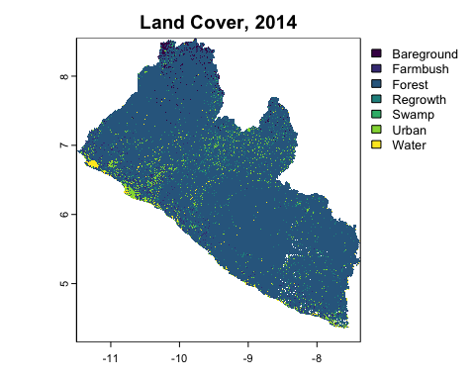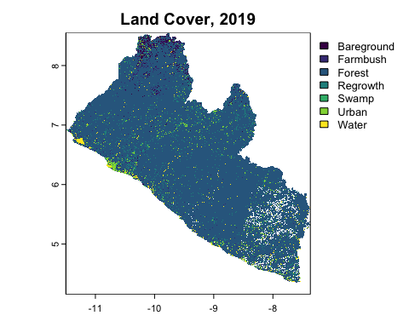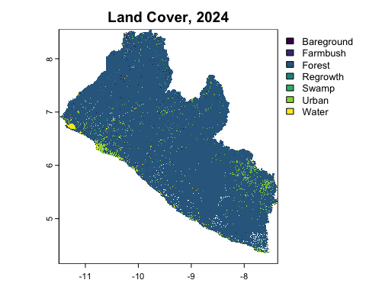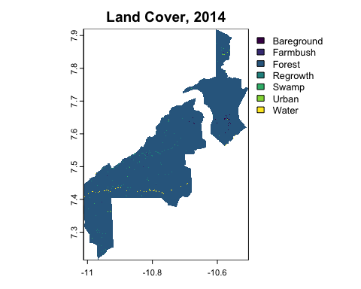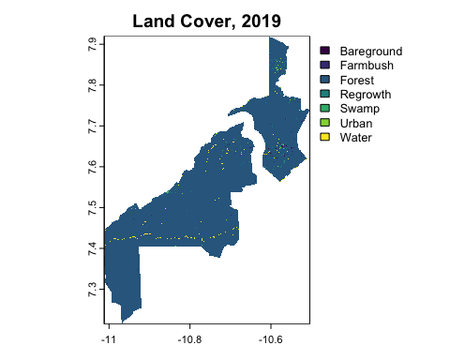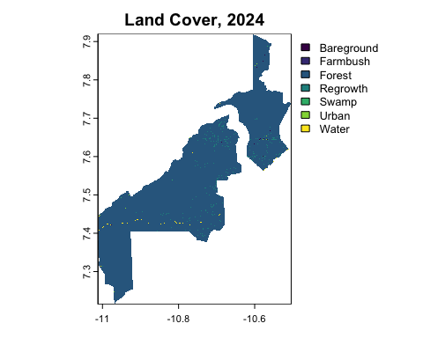

### Forest area estimates

# project for hectares  
LULC_LIBERIA_2014 = terra::project(LULC_LIBERIA_2014, "EPSG:32629")  
LULC_LIBERIA_2019 = terra::project(LULC_LIBERIA_2019, "EPSG:32629")  
LULC_LIBERIA_2024 = terra::project(LULC_LIBERIA_2024, "EPSG:32629")  
# Forest binary maps  
forest_class = 3  
forest_2014 <- LULC_LIBERIA_2014 == forest_class  
forest_2019 <- LULC_LIBERIA_2019 == forest_class  
forest_2024 <- LULC_LIBERIA_2024 == forest_class  
# Forest loss maps  
forest_loss_2014_2019_gross <- forest_2014 & !forest_2019  
forest_loss_2019_2024_gross <- forest_2019 & !forest_2024  
forest_gain_2014_2019_gross <- !forest_2014 & forest_2019  
forest_gain_2019_2024_gross <- !forest_2019 & forest_2024  
forest_loss_2014_2019 <- forest_loss_2014_2019_gross & !forest_gain_2014_2019_gross  
forest_loss_2019_2024 <- forest_loss_2019_2024_gross & !forest_gain_2019_2024_gross  
# Write to disk  
raster::writeRaster(forest_2014, "./data/BINARY/forest_2014.tif",overwrite=T)  
raster::writeRaster(forest_2019, "./data/BINARY/forest_2019.tif",overwrite=T)  
raster::writeRaster(forest_2024, "./data/BINARY/forest_2024.tif",overwrite=T)  
raster::writeRaster(forest_loss_2014_2019, "./data/BINARY/forest_loss_2014_2019.tif",overwrite=T)  
raster::writeRaster(forest_loss_2019_2024, "./data/BINARY/forest_loss_2019_2024.tif",overwrite=T)

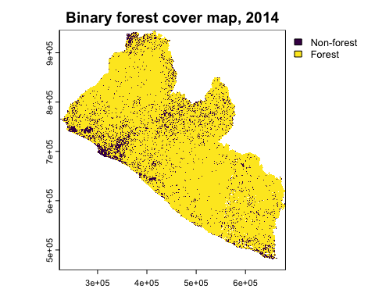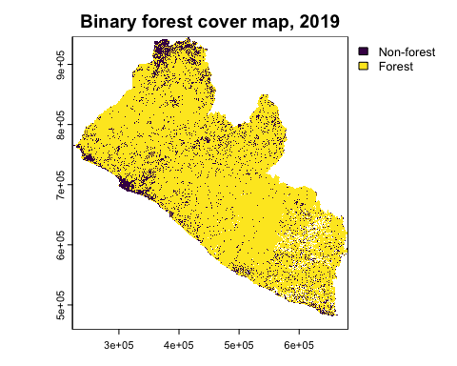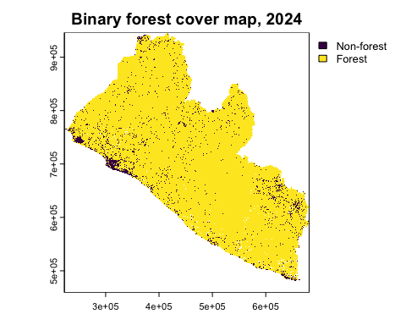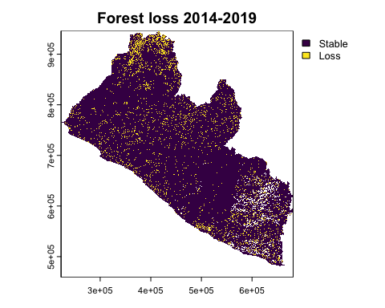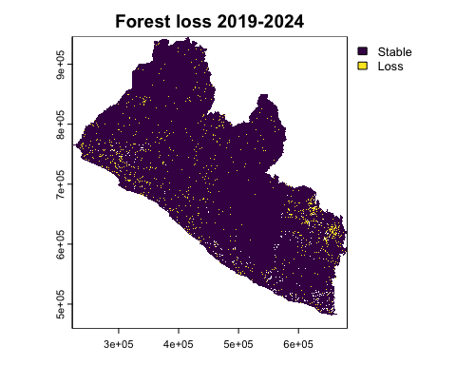

# Calculate total number of forest pixels for each year  
resolution <- terra::res(forest_2014)[1]  
forest_2014_estimate <- sum(forest_2014[], na.rm = TRUE) * resolution^2 / 10000  
forest_2019_estimate <- sum(forest_2019[], na.rm = TRUE) * resolution^2 / 10000  
forest_2024_estimate <- sum(forest_2024[], na.rm = TRUE) * resolution^2 / 10000  
forest_loss_2014_2019_estimate <- sum(forest_loss_2014_2019[],na.rm=T)*resolution^2/10000  
forest_loss_2019_2024_estimate <- sum(forest_loss_2019_2024[],na.rm=T)*resolution^2/10000  
cat("Total forest area across Liberia in 2014:", forest_2014_estimate, "hectares\n")  
cat("Total forest area across Liberia in 2019:", forest_2019_estimate, "hectares\n")  
cat("Total forest area across Liberia in 2024:", forest_2024_estimate, "hectares\n")  
cat("Total forest Loss across Liberia (2014-2019):", forest_loss_2014_2019_estimate, "hectares\n")  
cat("Total forest Loss across Liberia (2019-2024):", forest_loss_2019_2024_estimate, "hectares\n")

# Calculate forest area for each sub-region (in hectares) for all years  
forest_2014=terra::rast("./data/BINARY/forest_2014.tif")  
resolution <- terra::res(forest_2014)[1]  
forest_2014_gola_estimate <- sum(forest_2014_gola[], na.rm = TRUE) * resolution^2 / 10000  
forest_2014_tong_estimate <- sum(forest_2014_tong[], na.rm = TRUE) * resolution^2 / 10000  
forest_2014_norm_estimate <- sum(forest_2014_norm[], na.rm = TRUE) * resolution^2 / 10000  
forest_2014_project_estimate <- sum(forest_2014_project[], na.rm = TRUE) * resolution^2 / 10000  
forest_2019_gola_estimate <- sum(forest_2019_gola[], na.rm = TRUE) * resolution^2 / 10000  
forest_2019_tong_estimate <- sum(forest_2019_tong[], na.rm = TRUE) * resolution^2 / 10000  
forest_2019_norm_estimate <- sum(forest_2019_norm[], na.rm = TRUE) * resolution^2 / 10000  
forest_2019_project_estimate <- sum(forest_2019_project[], na.rm = TRUE) * resolution^2 / 10000  
forest_2024_gola_estimate <- sum(forest_2024_gola[], na.rm = TRUE) * resolution^2 / 10000  
forest_2024_tong_estimate <- sum(forest_2024_tong[], na.rm = TRUE) * resolution^2 / 10000  
forest_2024_norm_estimate <- sum(forest_2024_norm[], na.rm = TRUE) * resolution^2 / 10000  
forest_2024_project_estimate <- sum(forest_2024_project[], na.rm = TRUE) * resolution^2 / 10000  
  
# Calculate forest loss for each sub-region (in hectares) for all periods  
forest_loss_2014_2019_gola_estimate<-sum(forest_loss_2014_2019_gola[],na.rm=T)*resolution^2/10000  
forest_loss_2014_2019_tong_estimate <- sum(forest_loss_2014_2019_tong[],na.rm=T)*resolution^2/10000  
forest_loss_2014_2019_norm_estimate <- sum(forest_loss_2014_2019_norm[],na.rm=T)*resolution^2/10000  
forest_loss_2014_2019_project_estimate <- sum(forest_loss_2014_2019_project[],na.rm=T)*resolution^2/10000  
forest_loss_2019_2024_gola_estimate<- sum(forest_loss_2019_2024_gola[],na.rm=T)*resolution^2/10000  
forest_loss_2019_2024_tong_estimate <- sum(forest_loss_2019_2024_tong[],na.rm=T)*resolution^2/10000  
forest_loss_2019_2024_norm_estimate <- sum(forest_loss_2019_2024_norm[],na.rm=T)*resolution^2/10000  
forest_loss_2019_2024_project_estimate <- sum(forest_loss_2019_2024_project[],na.rm=T)*resolution^2/10000  
forest_loss_2014_2024_gola_estimate <- sum(forest_loss_2014_2024_gola[],na.rm=T)*resolution^2/10000  
forest_loss_2014_2024_tong_estimate <- sum(forest_loss_2014_2024_tong[],na.rm=T)*resolution^2/10000  
forest_loss_2014_2024_norm_estimate <- sum(forest_loss_2014_2024_norm[],na.rm=T)*resolution^2/10000  
forest_loss_2014_2024_project_estimate <- sum(forest_loss_2014_2024_project[],na.rm=T)*resolution^2/10000  
  
# Print out the forest area and loss estimates for each region and year  
cat("Forest Area in Gola NP (2014):", forest_2014_gola_estimate, "hectares\n")

Forest Area in Gola NP (2014): 87433.22 hectares

cat("Forest Area in Tonglay (2014):", forest_2014_norm_estimate, "hectares\n")

Forest Area in Tonglay (2014): 11958.54 hectares

cat("Forest Area in Norman (2014):", forest_2014_tong_estimate, "hectares\n")

Forest Area in Norman (2014): 19261.06 hectares

cat("Forest Area in Project (2014):", forest_2014_project_estimate, "hectares\n")

Forest Area in Project (2014): 118458.4 hectares

cat("Forest Area in Gola NP (2019):", forest_2019_gola_estimate, "hectares\n")

Forest Area in Gola NP (2019): 87617.41 hectares

cat("Forest Area in Tonglay (2019):", forest_2019_tong_estimate, "hectares\n")

Forest Area in Tonglay (2019): 18643.82 hectares

cat("Forest Area in Norman (2019):", forest_2019_norm_estimate, "hectares\n")

Forest Area in Norman (2019): 11658.63 hectares

cat("Forest Area in Project (2019):", forest_2019_project_estimate, "hectares\n")

Forest Area in Project (2019): 117729.2 hectares

cat("Forest Area in Gola NP (2024):", forest_2024_gola_estimate, "hectares\n")

Forest Area in Gola NP (2024): 87253.73 hectares

cat("Forest Area in Tonglay (2024):", forest_2024_tong_estimate, "hectares\n")

Forest Area in Tonglay (2024): 18844.98 hectares

cat("Forest Area in Norman (2024):", forest_2024_norm_estimate, "hectares\n")

Forest Area in Norman (2024): 12065.03 hectares

cat("Forest Area in Project (2024):", forest_2024_project_estimate, "hectares\n")

Forest Area in Project (2024): 117978.7 hectares

cat("Forest Loss in Gola NP (2014-2019):", forest_loss_2014_2019_gola_estimate, "hectares\n")

Forest Loss in Gola NP (2014-2019): 717.0632 hectares

cat("Forest Loss in Tonglay (2014-2019):", forest_loss_2014_2019_tong_estimate, "hectares\n")

Forest Loss in Tonglay (2014-2019): 679.6736 hectares

cat("Forest Loss in Norman (2014-2019):", forest_loss_2014_2019_norm_estimate, "hectares\n")

Forest Loss in Norman (2014-2019): 418.124 hectares

cat("Forest Loss in Project (2014-2019):", forest_loss_2014_2019_project_estimate, "hectares\n")

Forest Loss in Project (2014-2019): 1812.019 hectares

cat("Forest Loss in Gola NP (2019-2024):", forest_loss_2019_2024_gola_estimate, "hectares\n")

Forest Loss in Gola NP (2019-2024): 1194.424 hectares

cat("Forest Loss in Tonglay (2019-2024):", forest_loss_2019_2024_tong_estimate, "hectares\n")

Forest Loss in Tonglay (2019-2024): 463.9507 hectares

cat("Forest Loss in Norman (2019-2024):", forest_loss_2019_2024_norm_estimate, "hectares\n")

Forest Loss in Norman (2019-2024): 48.66864 hectares

cat("Forest Loss in Project (2019-2024):", forest_loss_2019_2024_project_estimate, "hectares\n")

Forest Loss in Project (2019-2024): 1700.205 hectares

cat("Forest Loss in Gola NP (2014-2024):", forest_loss_2014_2024_gola_estimate, "hectares\n")

Forest Loss in Gola NP (2014-2024): 115.6324 hectares

cat("Forest Loss in Tonglay (2014-2024):", forest_loss_2014_2024_tong_estimate, "hectares\n")

Forest Loss in Tonglay (2014-2024): 117.6751 hectares

cat("Forest Loss in Norman (2014-2024):", forest_loss_2014_2024_norm_estimate, "hectares\n")

Forest Loss in Norman (2014-2024): 66.78617 hectares

cat("Forest Loss in Project (2014-2024):", forest_loss_2014_2024_project_estimate, "hectares\n")

Forest Loss in Project (2014-2024): 300.893 hectares

## Allocated deforestation risk

The following spatial covariates were imported and processed as potential drivers of deforestation risk. Covariates were merged between sociodemographic and geographic datasets surrounding the project area and national level datasets beyond the project area in order to enable jurisdictions analysis.

Further updates are expected to these spatial coveriates pending delivery of proprietary data from the client. We also recommend that these mapping and risk assessments be revised or replaced prior to submission of PD, and following the release of Liberia’s Activity Data and jurisdictional deforestation risk maps [planned by Verra in Q3 of 2025](https://verra.org/methodologies-main/allocated-deforestation-risk-maps-timetable). For collective review, final covariates were visualized in the following interactive map.

#### Demography & topography

##############################  
##### Covariate wrangling#####  
##############################  
  
##### Download sociodemography  
pop_url <- "https://jeodpp.jrc.ec.europa.eu/ftp/jrc-opendata/GHSL/GHS_POP_GLOBE_R2023A/GHS_POP_E2025_GLOBE_R2023A_54009_1000/V1-0/GHS_POP_E2025_GLOBE_R2023A_54009_1000_V1_0.zip"   
osm_url <- "https://download.geofabrik.de/africa/liberia-latest-free.shp.zip"   
  
##### Built Environment  
places_points_project=sf::st_read("./data/Winrock_GIS/Communities_8km.shp")|>  
 st_cast("POINT")|>dplyr::select(name,fclass)|>rename(place=fclass)|>  
 mutate(place = as.factor(place)) |> mutate(name = as.character(name))  
  
places_points_liberia_1=sf::st_read("./data/liberia-osmdata/liberia_point.shp")|>  
 st_cast("POINT")|>sf::st_intersection(country)|>  
 dplyr::select(name,place)|>  
 dplyr::mutate(place = as.factor(place)) |>   
 dplyr::mutate(name = as.character(name))  
  
places_points_liberia_2 <- sf::st_read("./data/liberia-osmdata/gis_osm_places_free_1.shp")|>  
 st_cast("POINT")|>sf::st_intersection(country)|>  
 dplyr::select(name,fclass)|>  
 dplyr::rename(place=fclass)|>  
 dplyr::mutate(place = as.factor(place))|>   
 dplyr::mutate(name = as.character(name))  
  
places_worship <- sf::st_read("./data/liberia-osmdata/gis_osm_pofw_free_1.shp") |>  
 sf::st_intersection(country)|>  
 dplyr::select(name,fclass)|>  
 dplyr::rename(creed=fclass) |>   
 dplyr::mutate(creed=as.factor(creed)) |>   
 dplyr::mutate(name = as.character(name)) |>   
 st_cast("POINT")  
  
places_points <- places_points_project %>%  
 bind_rows(places_points_liberia_1,places_points_liberia_2, places_worship) %>%  
 group_by(across(-geometry)) %>%  
 summarise(geometry = st_union(geometry), .groups = "drop")  
places_points = sf::st_cast(places_points, "POINT")  
sf::st_write(places_points, "./data/covariates/places_points.shp", delete_dsn=T)  
  
##### Administrative Boundaries  
places_poly_liberia <- sf::st_read("./data/liberia-osmdata/liberia_poly.shp")|>st_cast("GEOMETRY")  
places_poly_county <- places_poly_liberia[st_geometry_type(places_poly_liberia) %in% c("POLYGON", "MULTIPOLYGON"), ] |>  
 sf::st_intersection(country)|>  
 dplyr::select(name,place,admin_leve)|>  
 dplyr::mutate(place = as.factor(place)) |>   
 dplyr::mutate(name = as.character(name)) |>  
 dplyr::rename(admin_level = admin_leve) |>  
 dplyr::filter(admin_level == "4")   
places_poly_county <- places_poly_county[st_geometry_type(places_poly_county) %in% c("POLYGON", "MULTIPOLYGON"), ] |>  
 sf::st_cast("MULTIPOLYGON")  
sf::st_write(places_poly_county, "./data/covariates/places_poly_county.shp", delete_dsn=T)   
  
places_poly_district <- places_poly_liberia[st_geometry_type(places_poly_liberia) %in% c("POLYGON", "MULTIPOLYGON"), ] |>  
 st_cast("POLYGON")|>sf::st_intersection(country)|>  
 dplyr::select(name,place,admin_leve)|>  
 dplyr::mutate(place = as.factor(place)) |>   
 dplyr::mutate(name = as.character(name)) |>  
 dplyr::rename(admin_level = admin_leve) |>  
 dplyr::filter(admin_level == "6")  
places_poly_district <- places_poly_district[st_geometry_type(places_poly_district) %in% c("POLYGON", "MULTIPOLYGON"), ] |>  
 sf::st_cast("MULTIPOLYGON")  
sf::st_write(places_poly_district, "./data/covariates/places_poly_district.shp", delete_dsn=T)   
  
buildings_private <- sf::st_read("./data/liberia-osmdata/gis_osm_buildings_a_free_1.shp") |>   
 sf::st_intersection(country) |> sf::st_simplify(preserveTopology = FALSE, dTolerance = 1000) |>  
 dplyr::select(name,fclass) |>  
 dplyr::rename(place = fclass) |>   
 dplyr::mutate(place = as.factor(place))|>   
 dplyr::mutate(name = as.character(name)) |>  
 st_cast("MULTIPOLYGON")   
sf::st_write(buildings_private, "./data/covariates/buildings_private.shp", delete_dsn=T)  
  
buildings_public <- sf::st_read("./data/liberia-osmdata/gis_osm_pois_a_free_1.shp") |>  
 sf::st_intersection(country) |>  
 dplyr::select(name,fclass) |>  
 dplyr::rename(place = fclass) |>   
 dplyr::mutate(place = as.factor(place))|>   
 dplyr::mutate(name = as.character(name)) |>  
 st_cast("MULTIPOLYGON")   
sf::st_write(buildings_public, "./data/covariates/buildings_public.shp", delete_dsn=T)  
  
buildings_merged <- buildings_private |> bind_rows(buildings_public) |>  
 group_by(across(-geometry)) |> summarise(geometry = st_union(geometry), .groups = "drop")  
buildings_merged = sf::st_cast(buildings_merged, "POLYGON")  
sf::st_write(buildings_merged, "./data/covariates/buildings.shp", delete_dsn=T)  
  
  
###### Waterways   
waterways_liberia = sf::st_read("./data/liberia-osmdata/gis_osm_waterways_free_1.shp") |>  
 sf::st_intersection(bbox_country) |>  
 dplyr::select(name,fclass) |>  
 dplyr::mutate(fclass = as.factor(fclass))|>   
 dplyr::mutate(name = as.character(name))  
waterways_liberia <- waterways_liberia[st_geometry_type(waterways_liberia) %in% c("LINESTRING", "MULTILINESTRING"), ] |>  
 st_cast("MULTILINESTRING")   
  
waterways_project = sf::st_read("./data/Winrock_GIS/PA_river.shp") |>  
 sf::st_intersection(bbox_country) |>  
 dplyr::select(name,fclass) |>  
 dplyr::mutate(fclass = as.factor(fclass))|>   
 dplyr::mutate(name = as.character(name))  
waterways_project <- waterways_project[st_geometry_type(waterways_project) %in% c("LINESTRING", "MULTILINESTRING"), ] |>  
 st_cast("MULTILINESTRING")   
  
waterways_merged <- waterways_liberia |> bind_rows(waterways_project) |>  
 group_by(across(-geometry)) |> summarise(geometry = st_union(geometry), .groups = "drop")  
waterways_merged = sf::st_cast(waterways_merged, "MULTILINESTRING")  
sf::st_write(waterways_merged, "./data/covariates/waterways_merged.shp", delete_dsn=T)  
  
waterbodies_collection = sf::st_read("./data/liberia-osmdata/gis_osm_water_a_free_1.shp") |>   
 sf::st_intersection(bbox_country) |>  
 dplyr::select(name,fclass) |>  
 dplyr::mutate(fclass = as.factor(fclass))|>   
 dplyr::mutate(name = as.character(name))  
waterbodies_poly <- waterbodies_collection[st_geometry_type(waterbodies_collection) %in% c("POLYGON", "MULTIPOLYGON"), ]   
waterbodies_lines <- waterbodies_collection[st_geometry_type(waterbodies_collection) %in% c("LINESTRING", "MULTILINESTRING"), ]   
waterbodies_poly_lines = sf::st_boundary(waterbodies_poly)  
  
waterbodies_waterways_merged <- waterbodies_lines |> bind_rows(waterbodies_poly_lines, waterways_merged) |>  
 group_by(across(-geometry)) |> summarise(geometry = st_union(geometry), .groups = "drop")  
waterbodies_waterways_merged = sf::st_cast(waterbodies_waterways_merged, "MULTILINESTRING")  
sf::st_write(waterbodies_waterways_merged, "./data/covariates/waterbodies_waterways_merged.shp", delete_dsn=T)  
  
  
###### Transport & Infrastructure  
transport = sf::st_read("./data/liberia-osmdata/gis_osm_transport_a_free_1.shp") |> sf::st_boundary() |>  
 sf::st_intersection(bbox_country) |>  
 dplyr::select(name,fclass) |>  
 dplyr::mutate(fclass = as.factor(fclass))|>   
 dplyr::mutate(name = as.character(name))  
  
railways = sf::st_read("./data/liberia-osmdata/gis_osm_railways_free_1.shp") |>  
 sf::st_intersection(bbox_country) |>  
 dplyr::select(name,fclass) |>  
 dplyr::mutate(fclass = as.factor(fclass))|>   
 dplyr::mutate(name = as.character(name))  
  
roads_liberia = sf::st_read("./data/liberia-osmdata/gis_osm_roads_free_1.shp") |>  
 sf::st_intersection(bbox_country) |>  
 dplyr::select(name,fclass) |>  
 dplyr::mutate(fclass = as.factor(fclass))|>   
 dplyr::mutate(name = as.character(name))  
  
roads_project = sf::st_read("./data/Winrock_GIS/PA_roads.shp") |>  
 sf::st_intersection(bbox_country) |>  
 dplyr::select(name,fclass) |>  
 dplyr::mutate(fclass = as.factor(fclass))|>   
 dplyr::mutate(name = as.character(name))  
  
roads_rail_transport_merged <- transport |> bind_rows(railways, roads_liberia, roads_project) |>  
 group_by(across(-geometry)) |> summarise(geometry = st_union(geometry), .groups = "drop")  
roads_rail_transport_merged = sf::st_cast(roads_rail_transport_merged, "MULTILINESTRING")  
sf::st_write(roads_rail_transport_merged, "./data/covariates/roads_rail_transport_merged.shp", delete_dsn=T)  
  
##### Slope / Elevation  
dem = raster::subset(STACK, "DEM")  
slope_tangent = raster::terrain(  
 dem, opt="slope",unit="tangent",neighbors=8,filename="./data/DEM/slope_tangent.tif")  
slope_tangent = terra::rast("./data/DEM/slope_tangent.tif")  
slope_percent = slope_tangent * 100  
slope_percent = terra::clamp(slope_percent, 0, 100)   
slope_percent = raster::raster(slope_percent)  
raster::writeRaster(slope_percent, "./data/covariates/slope_percent.tif")  
  
urban <- terra::mask(LULC_LIBERIA_2024, LULC_LIBERIA_2024 == 4, maskvalue = FALSE)  
urban <- raster::raster(urban)  
raster::writeRaster(urban, "./data/covariates/urban.tif", overwrite=T)

Reading layer `places_poly_county' from data source   
 `/Users/seamus/repos/rspb-redd-risk-new/data/covariates/places_poly_county.shp'   
 using driver `ESRI Shapefile'  
Simple feature collection with 16 features and 3 fields  
Geometry type: POLYGON  
Dimension: XY  
Bounding box: xmin: -11.50675 ymin: 4.353908 xmax: -7.367323 ymax: 8.551925  
Geodetic CRS: WGS 84

Reading layer `places_points' from data source   
 `/Users/seamus/repos/rspb-redd-risk-new/data/covariates/places_points.shp'   
 using driver `ESRI Shapefile'  
Simple feature collection with 14258 features and 3 fields  
Geometry type: POINT  
Dimension: XY  
Bounding box: xmin: -11.47265 ymin: 4.356629 xmax: -7.451106 ymax: 8.532636  
Geodetic CRS: WGS 84

Reading layer `roads_rail_transport_merged' from data source   
 `/Users/seamus/repos/rspb-redd-risk-new/data/covariates/roads_rail_transport_merged.shp'   
 using driver `ESRI Shapefile'  
Simple feature collection with 510 features and 2 fields  
Geometry type: MULTILINESTRING  
Dimension: XY  
Bounding box: xmin: -11.57036 ymin: 4.358714 xmax: -7.288387 ymax: 8.596912  
Geodetic CRS: WGS 84

Reading layer `waterbodies_waterways_merged' from data source   
 `/Users/seamus/repos/rspb-redd-risk-new/data/covariates/waterbodies_waterways_merged.shp'   
 using driver `ESRI Shapefile'  
Simple feature collection with 135 features and 2 fields  
Geometry type: MULTILINESTRING  
Dimension: XY  
Bounding box: xmin: -11.5291 ymin: 4.36122 xmax: -7.155285 ymax: 8.582564  
Geodetic CRS: WGS 84

#### Annualized deforestation

# Assign zones  
zones_sf = counties |> sf::st_transform("EPSG:32629")  
zones_sf$zone_id <- 1:nrow(zones_sf)  
zones_sv <- terra::vect(zones_sf)  
  
# Calculate zonal annualization by jurisdiction  
forest_2024 = terra::rast("./data/BINARY/forest_2024.tif")  
forest_loss_2014_2019 = terra::rast("./data/BINARY/forest_loss_2014_2019.tif")  
forest_loss_2019_2024 = terra::rast("./data/BINARY/forest_loss_2019_2024.tif")  
forest_loss_2014_2024 = terra::rast("./data/BINARY/forest_loss_2014_2024.tif")  
pixel_area_ha <- 0.088914 # 29.80124 x 29.80124 m² converted to hectares  
  
zonal_2014_2019 <- terra::extract(forest_loss_2014_2019,zones_sv,fun=sum,na.rm=T)  
zonal_2019_2024 <- terra::extract(forest_loss_2019_2024,zones_sv,fun=sum,na.rm=T)  
names(zonal_2014_2019) <- c("zone_id", "loss_2014_2019")  
names(zonal_2019_2024) <- c("zone_id", "loss_2019_2024")  
zonal_2014_2019$loss_2014_2019 <- zonal_2014_2019$loss_2014_2019 * pixel_area_ha  
zonal_2019_2024$loss_2019_2024 <- zonal_2019_2024$loss_2019_2024 * pixel_area_ha  
  
# Merge baseline years  
zonal_stats <- merge(  
 zonal_2014_2019, # e.g. (zone_id, loss_2014_2019)  
 zonal_2019_2024, # e.g. (zone_id, loss_2019_2024)  
 by = "zone_id", # Common ID column  
 all = TRUE # Keep all rows if zones differ  
)  
# Annualize 10-year total & rejoin to sf object  
zonal_stats$loss_10yr <- zonal_stats$loss_2014_2019 + zonal_stats$loss_2019_2024  
zonal_stats$annual_loss_10yr <- zonal_stats$loss_10yr / 10  
zones_sf <- merge(zones_sf, zonal_stats, by="zone_id", all.x=TRUE)  
head(zones_sf[, c("zone_id", "loss_2014_2019", "loss_2019_2024",   
 "loss_10yr", "annual_loss_10yr")])  
  
# Derive 10-yr annualized raster  
zones_sv <- terra::vect(zones_sf)  
annual_loss_10yr_raster <- rasterize(  
 zones_sv, # polygon SpatVector  
 forest_loss_2014_2019, # template raster for resolution/extent  
 field = "annual_loss_10yr") # the column to rasterize  
names(annual_loss_10yr_raster) <- ("annual_loss_10yr")  
raster::writeRaster(annual_loss_10yr_raster,"./data/BINARY/annual_loss_2014_2024_zonal.tif",overwrite=T)

#### Distance covariates

# Derive distance-to-edge raster   
forest_2024 = terra::rast("./data/BINARY/forest_2024.tif")  
forest_mask <- terra::classify(forest_2024, cbind(c(1,0), c(1,NA)))  
nonForest_mask <- terra::classify(forest_2024, cbind(c(1,0), c(NA,1)))  
writeRaster(forest_mask, "./data/BINARY/forest_mask.tif", overwrite=T)  
writeRaster(nonForest_mask, "./data/BINARY/nonForest_mask.tif", overwrite=T)  
  
forest_for_distance <- forest_mask  
forest_for_distance_raster <- raster::raster(forest_for_distance)   
distance_to_edge <- distance(forest_for_distance_raster, filename="./data/BINARY/distance_to_edge_unix.tif")  
  
# Derive distance-to-feature rasters  
template <- forest_2024  
roads_rast <- rasterize(vect(transport), template, field=1, background=0)  
roads_rast <- subst(roads_rast, from=0, to=NA)  
distance_to_roads <- distance(roads_rast)  
writeRaster(distance_to_roads, "./data/LULC/distance_to_roads.tif", overwrite=T)  
  
places_vect <- sf::st_read("./data/BINARY/places.shp") |> terra::vect()  
places_rast <- rasterize(places_vect,template,field=1,background=0,touches=T)  
places_rast <- subst(places_rast, from=0, to=NA)  
distance_to_places<- distance(places_rast)  
writeRaster(distance_to_places, "./data/LULC/distance_to_places.tif", overwrite=T)  
  
waterways_rast<-rasterize(vect(waterways_rast), template, field=1, background=0)  
waterways_rast<-subst(waterways_rast, from=0, to=NA)  
distance_to_waterways<-distance(waterways_rast)  
writeRaster(distance_to_waterways, "./data/LULC/distance_to_waterways.tif", overwrite=T)  
  
urban_rast <- raster::raster(urban)  
urban_rast <- subst(urban_rast, from=0, to=NA)  
distance_to_urban <- distance(urban_rast)  
writeRaster(distance_to_urban, "./data/LULC/distance_to_urban.tif", overwrite=T)  
  
# Normalize covariates for quicker computing  
normalize <- function(x){  
 (x-global(x,"min",na.rm=T))/  
 (global(x,"max",na.rm=T) -  
 global(x, "min",na.rm=T))}  
  
population= raster::raster(population)  
population= normalize_function(population)  
slope = raster::raster(slope)  
slope = normalize_function(slope)  
  
distance_to_forest = normalize_function(distance_to_forest)  
distance_to_roads = normalize_function(distance_to_roads)  
distance_to_places = normalize_function(distance_to_places)  
distance_to_water = normalize_function(distance_to_waterways)  
distance_to_urban = normalize_function(distance_to_urban)  
  
# invert all risk-producing covariates  
distance_to_edge_inv <- 1 - distance_to_forest  
distance_to_roads_inv <- 1 - distance_to_roads  
distance_to_places_inv <- 1 - distance_to_places  
distance_to_water_inv <- 1 - distance_to_waterways  
distance_to_urban_inv <- 1 - distance_to_urban  
  
writeRaster(distance_to_edge_inv, "./data/BINARY/distance_to_edge_inverted.tif", overwrite=T)  
writeRaster(distance_to_roads_inv, "./data/BINARY/distance_to_roads_inverted.tif", overwrite=T)  
writeRaster(distance_to_places_inv, "./data/BINARY/distance_to_places_inverted.tif", overwrite=T)  
writeRaster(distance_to_water_inv, "./data/BINARY/distance_to_water_inverted.tif", overwrite=T)  
writeRaster(distance_to_urban_inv, "./data/BINARY/distance_to_urban_inverted.tif", overwrite=T)  
writeRaster(slope_norm, "./data/BINARY/slope_norm.tif", overwrite=T)



#### Deforestation risk & allocation

Two methods were explored for weighting variables and creating a generalized deforestation risk index. We could consider developing a spatial risk model using the spatstat package or logistic regression, as has been cited in recent Verra guides. In addition, some of the heavy lifting with input formatting and data wrangling has already been completed.

However, spatial modelling has tended to produce challenges when fitting such large country-wide covariates. Moreover, these kinds of spatialy driven models tend to require longer training procedures due to their intercept-based spatial kernels and slower resampling patterns.

Alternatively, we have drafted a tentative risk indexing approach based on a weighted sum of subjectively scored covariate effects. While each variable would still need a carefully reasoned score, this option offers a more streamlined method that is easier to adjust. We applied this risk index to inform a risk weighted allocation of the 10-year deforestation rate, first by multiplying the fraction of pixel risk by zonal forest loss, and second by factoring out annual zonal loss by multiplying by pixel risk values, as shown below

$${AllocatedLoss}_{pixel}=\left(\frac{{risk}_{pixel}}{∑{risk}_{zone}}\right)×{annual_loss_10yr}_{zone}$$

$${allocated_loss}_{pixel}={risk}_{pixel}×\left(\frac{{annual_loss_10yr}_{zone}}{∑{risk}_{zone}}\right)$$

Both formulas describe the same operation in different orders of multiplication: each pixel in a given zone Z receives a share of annual_loss_10yrZ based on its proportional risk (the pixel’s risk relative to the sum of all pixel risks in that zone). This ensures that higher-risk pixels are allocated more deforestation, in line with the Verra guidance for an allocated deforestation risk map.

We intend to present both of these approaches for broader review and discussion in our upcoming meeting.

risk_index <- (0.2 * distance_to_edge) +  
 (0.2 * distance_to_roads) +  
 (0.2 * distance_to_places) +  
 (0.1 * distance_to_urban) +  
 (0.1 * distance_to_water) +  
 (0.1 * slope)  
  
# Re-normalize the index to between 0 and 1  
rmin <- global(risk_index, "min", na.rm=TRUE)[1]  
rmax <- global(risk_index, "max", na.rm=TRUE)[1]  
risk_index_norm <- (risk_index - rmin) / (rmax - rmin)  
writeRaster(risk_index_norm, "./data/BINARY/deforestation_risk_index.tif",overwrite=T)  
  
# Returns a data.frame with columns: ID, risk_index_norm_sum  
risk_sum <- extract(risk_index_norm, zones_sv, fun = sum, na.rm=TRUE)  
colnames(risk_sum) <- c("zone_id","sum_risk")  
zones_stats <- merge(zones_sf, risk_sum, by="zone_id", all.x=TRUE)  
zones_rast <- rasterize(vect(zones_stats), risk_index_norm, field="zone_id")  
zones_stats$loss_factor <- zones_stats$annual_loss_10yr / zones_stats$sum_risk  
loss_factor_rast <- rasterize(vect(zones_stats), risk_index_norm, field="loss_factor")  
allocated_loss <- risk_index_norm * loss_factor_rast  
writeRaster(allocated_loss, "./data/BINARY/allocated_deforestation.tif", overwrite=T)  
  
# Visualize  
terra::plot(risk_index_norm, main="Deforestation risk map")  
terra::plot(allocated_loss, main="Allocated deforestation map")

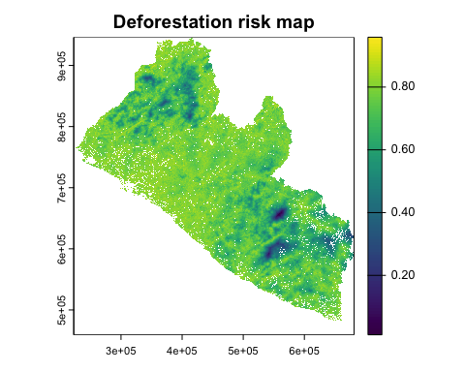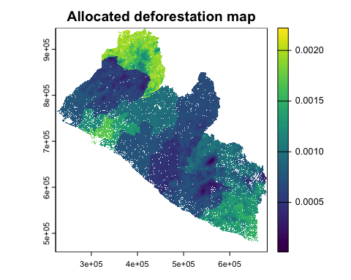

### Appendix

***2019 and 2024 classifiers***

To run these, you may change eval=F to eval=T at the top of chunk in the .Rmd or .R file saved in the OneDrive folder.

########################### 2019  
# extract signatures  
signatures_2019 = raster::extract(STACK_2019, samples ,df=T) # watch for data formats  
samples_signatures_2019 <- dplyr::inner_join(signatures_2019, samples, by=c("ID"="id"))  
samples_signatures_2019$geometry <- NULL # set geometry to NULL for model training  
  
# training-test split, p=0.7 -> 70% split  
partitioned_data_2019 <- stratified_partition(samples_signatures_2019,group_col="label", train_ratio=0.7)  
trainData_2019 <- partitioned_data_2019$train  
testData_2019 <- partitioned_data_2019$test  
table(trainData_2019$label)  
table(testData_2019$label)  
  
# synthetic minority oversampling technique  
trainData_2019<-performanceEstimation::smote(label ~ .,data=trainData_2019,perc.over=10, perc.under=100)  
testData_2019<-performanceEstimation::smote(label ~ .,data=testData_2019,perc.over=10,perc.under=100)  
# interpolate NAs with class-median-normalization (NAs -> missing cloud pixels)  
trainData_2019 <- trainData_2019 |> group_by(label) |> mutate(across(where(is.numeric),  
 ~ ifelse(is.na(.), median(., na.rm = TRUE), .))) |> ungroup()  
testData_2019 <- testData_2019 |> group_by(label) |> mutate(across(where(is.numeric),  
 ~ ifelse(is.na(.), median(., na.rm = TRUE), .))) |> ungroup()  
  
# assign model variables  
response <- c("label")  
predictors_2019 <- c(  
 "NDVI_2019", "BLUE_2019", "GREEN_2019", "RED_2019",   
 "NIR08_2019", "SWIR16_2019", "SWIR22_2019", "DEM"  
 )  
  
# train classifier  
rf_model_2019 <- caret::train(  
 label~.,  
 data = trainData_2019[, c(predictors_2019, "label")], # drop ID var  
 trControl = cv_regime,  
 method = "rf",   
 metric = 'Kappa',   
 ntree = 500,  
 tuneLength= 6,  
 importance= T  
 )  
  
rf_test_2019 <- predict(rf_model_2019, testData_2019)  
print(rf_model_2019) # cv results  
confusionMatrix(rf_test_2019,testData_2019$label) # blind test results  
  
index_feature_2019 <- createMultiFolds(trainData_2019$label, times=5)   
predictor_seq_2019 <-seq(from=1, to=length(predictors_2019),by=2)  
  
subset_regime_2019 <- rfeControl(  
 method="LGOCV",  
 number = 10,  
 verbose=FALSE,  
 functions=rfFuncs,  
 index=index_feature_2019  
 )  
  
rf_model_subset_2019 <- caret::rfe(  
 label~.,  
 data = trainData_2019[, c(predictors_2019, "label")],   
 sizes = predictor_seq_2019,  
 metric = "Kappa",  
 ntree=500,  
 method="rf",  
 rfeControl = subset_regime_2019  
 )  
  
rf_subset_test_2019 <- predict(rf_model_subset_2019,testData_2019)  
print(rf_model_subset_2019)  
confusionMatrix(rf_subset_test_2019$pred,testData_2019$label)  
  
######################### 2024  
# extract signatures  
signatures_2024 = raster::extract(STACK_2024, samples ,df=T) # watch for data formats  
samples_signatures_2024 <- dplyr::inner_join(signatures_2024, samples, by=c("ID"="id"))  
samples_signatures_2024$geometry <- NULL # set geometry to NULL for model training  
  
# training-test split, p=0.7 -> 70% split  
partitioned_data_2024 <- stratified_partition(samples_signatures_2024,group_col="label", train_ratio=0.7)  
trainData_2024 <- partitioned_data_2024$train  
testData_2024 <- partitioned_data_2024$test  
table(trainData_2024$label)  
table(testData_2024$label)  
  
# synthetic minority oversampling technique  
trainData_2024<-performanceEstimation::smote(label ~ .,data=trainData_2024,perc.over=10, perc.under=100)  
testData_2024<-performanceEstimation::smote(label ~ .,data=testData_2024,perc.over=10,perc.under=100)  
# interpolate missing cloud pixels with class-median-normalization  
trainData_2024 <- trainData_2024 |> group_by(label) |> mutate(across(where(is.numeric),  
 ~ ifelse(is.na(.), median(., na.rm = TRUE), .))) |> ungroup()  
testData_2024 <- testData_2024 |> group_by(label) |> mutate(across(where(is.numeric),  
 ~ ifelse(is.na(.), median(., na.rm = TRUE), .))) |> ungroup()  
  
# interpolate NAs with class-median-normalization (NAs -> missing cloud pixels)  
trainData_2024 <- trainData_2024 |> group_by(label) |> mutate(across(where(is.numeric),  
 ~ ifelse(is.na(.), median(., na.rm = TRUE), .))) |> ungroup()  
testData_2024 <- testData_2024 |> group_by(label) |> mutate(across(where(is.numeric),  
 ~ ifelse(is.na(.), median(., na.rm = TRUE), .))) |> ungroup()  
water_2014 <- trainData_2014[trainData_2014$label == "Water", ]  
water_ids <- water_2014$ID  
water_2024 <- samples_signatures_2024[samples_signatures_2024$ID %in% water_ids, ]  
trainData_2024 <- rbind(trainData_2024, water_2024)  
table(trainData_2024$label)  
  
# assign model variables  
response <- c("label")  
predictors_2024 <- c("NDVI_2024", "BLUE_2024", "GREEN_2024", "RED_2024",   
 "NIR08_2024", "SWIR16_2024", "SWIR22_2024", "DEM"  
 )  
  
# train classifier  
rf_model_2024 <- caret::train(  
 label~.,  
 data = trainData_2024[, c(predictors_2024, "label")], # drop ID var  
 trControl = cv_regime,  
 method = "rf",   
 metric = 'Kappa',   
 ntree = 500,  
 tuneLength= 6,  
 importance= T  
 )  
  
rf_test_2024 <- predict(rf_model_2024, testData_2024)  
print(rf_model_2024) # cv results  
confusionMatrix(rf_test_2024,testData_2024$label) # blind test results  
  
index_feature_2024 <- createMultiFolds(trainData_2024$label, times=5)   
predictor_seq_2024 <-seq(from=1, to=length(predictors_2024),by=2)  
  
subset_regime_2024 <- rfeControl(  
 method="LGOCV",  
 number = 10,  
 verbose=FALSE,  
 functions=rfFuncs,  
 index=index_feature_2024  
 )  
  
rf_model_subset_2024 <- caret::rfe(  
 label~.,  
 data = trainData_2024[, c(predictors_2024, "label")],   
 sizes = predictor_seq_2024,  
 metric = "Kappa",  
 ntree=500,  
 method="rf",  
 rfeControl = subset_regime_2024  
 )  
  
rf_subset_test_2024 <- predict(rf_model_subset_2024,testData_2024)  
print(rf_model_subset_2024)  
confusionMatrix(rf_subset_test_2024$pred,testData_2024$label)

LULC_LIBERIA_2014 <- raster::predict(STACK_2014,rf_model_2014, na.rm=TRUE) |> raster::raster()  
raster::writeRaster(LULC_LIBERIA_2014,"./data/LULC/LULC_LIBERIA_2014-01-04.tif",  
 format = "GTiff", overwrite = T)  
  
LULC_LIBERIA_2019 <- raster::predict(STACK_2019,rf_model_2019, na.rm=TRUE) |> raster::raster()   
raster::writeRaster(LULC_LIBERIA_2019,"./data/LULC/LULC_LIBERIA_2019-01-02.tif",  
 format = "GTiff",overwrite = T)  
  
LULC_LIBERIA_2024 <- raster::predict(STACK_2024,rf_model_2014, na.rm=TRUE) |> raster::raster()   
raster::writeRaster(LULC_LIBERIA_2024,"./data/LULC/LULC_LIBERIA_2024-01-16x.tif",  
 format = "GTiff",overwrite = T)

devtools::session_info()

Liberia, Government of. 2019. *Liberia’s Forest Reference Emission Level Submission to the UNFCCC*. 1. Forestry Development Authority.

Stanimirova, Radost, Katelyn Tarrio, Konrad Turlej, Kristina McAvoy, Sophia Stonebrook, Kai-Ting Hu, Paulo Arévalo, et al. 2023. “A Global Land Cover Training Dataset from 1984 to 2020.” *Scientific Data* 10 (1): 879. <https://doi.org/10.1038/s41597-023-02798-5>.

Verra. 2021. *VT0007: Unplanned Deforestation Allocation Tool*. 0.1. Verra. <https://verra.org/wp-content/uploads/2024/02/VT0007-Unplanned-Deforestation-Allocation-v1.0.pdf>.

———. 2023. *VM0048: Reducing Emissions from Deforestation and Forest Degradation*. 1.0. Verra. <https://verra.org/wp-content/uploads/2023/11/VM0048-Reducing-Emissions-from-Deforestation-and-Forest-Degradation-v1.0-1-1.pdf>.

———. 2024. *VMD0055: Estimation of Emission Reductions from Avoiding Unplanned Deforestation*. VCS Module 1.1. Verra. <https://verra.org/wp-content/uploads/2024/10/VMD0055-Estimation-of-Emission-Reductions-from-Avoiding-Unplanned-Deforestation-v1.1-CLEAN-2024.10.21.24.pdf>.

Woodcock, Curtis, Pontus Olofsson, Thomas Loveland, Chris Barber, and Zhe Zhu. n.d. “Global Land Cover Estimation (GLanCE) Product User Guide Version 1.0 August 2022.”

1. Please note that model performance metrics differ slightly with each runtime due to Monte Carlo resampling and the number of randomForest decision trees. This is to say that accuracy results in the chunk below may not be precisely matching the in-text reporting here if a new run has been implemented locally on your machine.